Hello World in Android Studio using GUI Components, Fonts and Colors
Expt. No: 01
Date:06/09/2021

Aim:
To implement hello world in android studio using GUI components, fonts and colours.

Software and Hardware Requirements:
Software:
- Android Studio
- Java
Hardware:
- Preferably 8GB+ RAM Laptop/Desktop

Algorithm:
1. Open Android Studio and create a new project.
2. Select Empty Activity.
3. In the text attribute mention the text that has to be displayed.
4. Background specifies the background colour

Code:

MainActivity.java:
package com.example.guiapplication;
import androidx.appcompat.app.AppCompatActivity;
import android.os.Bundle;
import android.view.View;
import android.widget.Button;
import android.widget.TextView;
import android.graphics.Color;
public class MainActivity extends AppCompatActivity {
int ch=1;
float font=30;
@Override
protected void onCreate(Bundle savedInstanceState)
{
super.onCreate(savedInstanceState);
setContentView(R.layout.activity_main);
final TextView t= (TextView) findViewById(R.id.textView);
Button b1= (Button) findViewById(R.id.button1);
b1.setOnClickListener(new View.OnClickListener() {
@Override
public void onClick(View v) {
t.setTextSize(font);
font = font + 5;
if (font == 50)
font = 30;
}
});
Button b2= (Button) findViewById(R.id.button2);
b2.setOnClickListener(new View.OnClickListener() {
@Override
public void onClick(View v) {
switch (ch) {
case 1:
t.setTextColor(Color.RED);
break;
case 2:
t.setTextColor(Color.GREEN);
break;
case 3:
t.setTextColor(Color.BLUE);
break;
case 4:
t.setTextColor(Color.CYAN);
break;
case 5:
t.setTextColor(Color.YELLOW);
break;
case 6:
t.setTextColor(Color.MAGENTA);
break;
}
ch++;
if (ch == 7)
ch = 1;
}
});
}
}

activity_main.xml:
<?xml version="1.0" encoding="utf-8"?>
<androidx.constraintlayout.widget.ConstraintLayout xmlns:android="http://schemas.android.com/apk/res/android"
xmlns:app="http://schemas.android.com/apk/res-auto"
xmlns:tools="http://schemas.android.com/tools"
android:layout_width="match_parent"
android:layout_height="match_parent"
android:background="@color/teal_200"
tools:context=".MainActivity">
<TextView
android:id="@+id/textView"
android:layout_width="wrap_content"
android:layout_height="wrap_content"
android:layout_margin="30dp"
android:gravity="center"
android:text="Welcome to our Application!"
android:textColor="@color/black"
android:textSize="34sp"
android:textStyle="bold"
app:layout_constraintBottom_toBottomOf="parent"
app:layout_constraintHorizontal_bias="0.417"
app:layout_constraintLeft_toLeftOf="parent"
app:layout_constraintRight_toRightOf="parent"
app:layout_constraintTop_toTopOf="parent"
app:layout_constraintVertical_bias="0.156" />
<Button
android:id="@+id/button1"
android:layout_width="301dp"
android:layout_height="51dp"
android:layout_margin="20dp"
android:gravity="center"
android:text="Change font size"
android:textSize="25sp"
app:layout_constraintBottom_toBottomOf="parent"
app:layout_constraintHorizontal_bias="0.545"
app:layout_constraintLeft_toLeftOf="parent"
app:layout_constraintRight_toRightOf="parent"
app:layout_constraintTop_toTopOf="parent"
app:layout_constraintVertical_bias="0.608" />
<Button
android:id="@+id/button2"
android:layout_width="308dp"
android:layout_height="52dp"
android:layout_margin="20dp"
android:gravity="center"
android:text="Change color"
android:textSize="25sp"
app:layout_constraintBottom_toBottomOf="parent"
app:layout_constraintHorizontal_bias="0.631"
app:layout_constraintLeft_toLeftOf="parent"
app:layout_constraintRight_toRightOf="parent"
app:layout_constraintTop_toTopOf="parent"
app:layout_constraintVertical_bias="0.883" />
</androidx.constraintlayout.widget.ConstraintLayout>

Sample I/O:

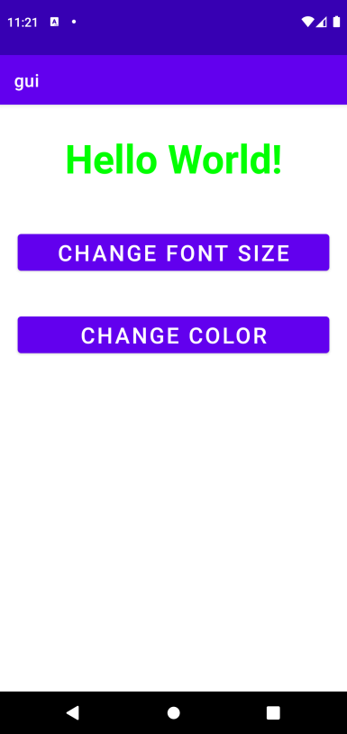

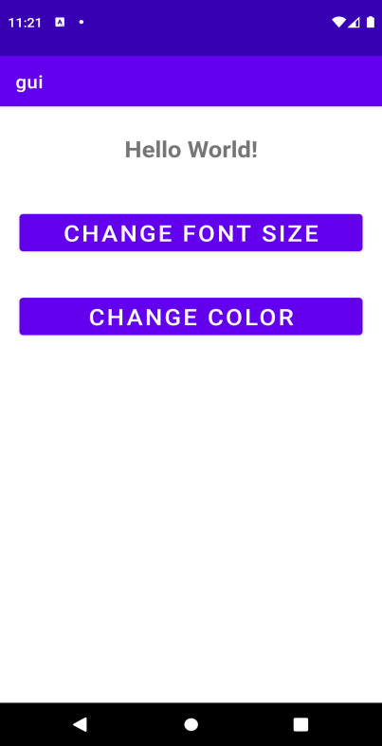

Result:
Thus, hello world was successfully implemented in Android Studio using GUI Components, fonts and colours.

Layout Managers and Event Listeners

Expt. No: 02
Date:13/09/2021

Aim:
To develop a Simple Android Application that uses Layout Managers and Event Listeners.

Software and Hardware Requirements:
Software:
- Android Studio
- Java
Hardware:
- Preferably 8GB+ RAM Laptop/Desktop

Algorithm:
- Open Android Studio and create a new project.
2) Select Empty Activity.
3) In this application, the activity implements Constraint Layout, Linear Layout, and Relative Layout
4) There are various event listeners like onclick, ondoubleclick, onlongPress, onTouch events. In this activity onclick is implemented.

Code:
Activity_main.xml:
<?xml version="1.0" encoding="utf-8"?>
<RelativeLayout xmlns:android="http://schemas.android.com/apk/res/android"
xmlns:tools="http://schemas.android.com/tools"
android:layout_width="match_parent"
android:layout_height="match_parent"
tools:context=".MainActivity">
<LinearLayout
android:layout_width="match_parent"
android:layout_height="100dp">
<TextView
android:id="@+id/textView"
android:layout_width="match_parent"
android:layout_height="wrap_content"
android:layout_margin="30dp"
android:text="Details Form"
android:textSize="25sp"
android:gravity="center"/>
</LinearLayout>
<GridLayout
android:id="@+id/gridLayout"
android:layout_width="match_parent"
android:layout_height="match_parent"
android:layout_marginTop="100dp"
android:layout_marginBottom="200dp"
android:columnCount="2"
android:rowCount="3">
<TextView
android:id="@+id/textView1"
android:layout_width="wrap_content"
android:layout_height="wrap_content"
android:layout_margin="10dp"
android:layout_row="0"
android:layout_column="0"
android:text="Name"
android:textSize="20sp"
android:gravity="center"/>
<EditText
android:id="@+id/editText"
android:layout_width="wrap_content"
android:layout_height="wrap_content"
android:layout_margin="10dp"
android:layout_row="0"
android:layout_column="1"
android:ems="10"/>
<TextView
android:id="@+id/textView2"
android:layout_width="wrap_content"
android:layout_height="wrap_content"
android:layout_margin="10dp"
android:layout_row="1"
android:layout_column="0"
android:text="Reg.No"
android:textSize="20sp"
android:gravity="center"/>
<EditText
android:id="@+id/editText2"
android:layout_width="wrap_content"
android:layout_height="wrap_content"
android:layout_margin="10dp"
android:layout_row="1"
android:layout_column="1"
android:inputType="number"
android:ems="10"/>
<TextView
android:id="@+id/textView3"
android:layout_width="wrap_content"
android:layout_height="wrap_content"
android:layout_margin="10dp"
android:layout_row="2"
android:layout_column="0"
android:text="Dept"
android:textSize="20sp"
android:gravity="center"/>
<Spinner
android:id="@+id/spinner"
android:layout_width="wrap_content"
android:layout_height="wrap_content"
android:layout_margin="10dp"
android:layout_row="2"
android:layout_column="1"
android:spinnerMode="dropdown"/>
</GridLayout>
<Button
android:id="@+id/button"
android:layout_width="wrap_content"
android:layout_height="wrap_content"
android:layout_alignParentBottom="true"
android:layout_centerInParent="true"
android:layout_marginBottom="150dp"
android:text="Submit"/>
</RelativeLayout>

Activity_second.xml:
<?xml version="1.0" encoding="utf-8"?>
<LinearLayout xmlns:android="http://schemas.android.com/apk/res/android"
xmlns:tools="http://schemas.android.com/tools"
android:layout_width="match_parent"
android:layout_height="match_parent"
tools:context="com.example.devang.exno2.SecondActivity"
android:orientation="vertical"
android:gravity="center">
<TextView
android:id="@+id/textView1"
android:layout_width="wrap_content"
android:layout_height="wrap_content"
android:layout_margin="20dp"
android:text="New Text"
android:textSize="30sp"/>
<TextView
android:id="@+id/textView2"
android:layout_width="wrap_content"
android:layout_height="wrap_content"
android:layout_margin="20dp"
android:text="New Text"
android:textSize="30sp"/>
<TextView
android:id="@+id/textView3"
android:layout_width="wrap_content"
android:layout_height="wrap_content"
android:layout_margin="20dp"
android:text="New Text"
android:textSize="30sp"/>
</LinearLayout>

SecondActivity.java:
package com.example.layoutmanager;
import androidx.appcompat.app.AppCompatActivity;
import android.content.Intent;
import android.widget.TextView;
import android.os.Bundle;
public class SecondActivity extends AppCompatActivity {
TextView t1,t2,t3;
String name,reg,dept;
@Override
protected void onCreate(Bundle savedInstanceState) {
super.onCreate(savedInstanceState);
setContentView(R.layout.activity_second);
t1= (TextView) findViewById(R.id.textView1);
t2= (TextView) findViewById(R.id.textView2);
t3= (TextView) findViewById(R.id.textView3);
//Getting the Intent
Intent i = getIntent();
//Getting the Values from First Activity using the Intent received
name=i.getStringExtra("name_key");
reg=i.getStringExtra("reg_key");
dept=i.getStringExtra("dept_key");
//Setting the Values to Intent
t1.setText(name);
t2.setText(reg);
t3.setText(dept);
}

MainActivity.java:
package com.example.layoutmanager;
import androidx.appcompat.app.AppCompatActivity;
import android.content.Intent;
import android.os.Bundle;
import android.view.View;
import android.widget.ArrayAdapter;
import android.widget.Button;
import android.widget.EditText;
import android.widget.Spinner;
public class MainActivity extends AppCompatActivity {
//Defining the Views
EditText e1,e2;
Button bt;
Spinner s;
//Data for populating in Spinner
String [] dept_array={"CSE","ECE","IT","Mech","Civil"};
String name,reg,dept;
@Override
protected void onCreate(Bundle savedInstanceState) {
super.onCreate(savedInstanceState);
setContentView(R.layout.activity_main);
//Referring the Views
e1= (EditText) findViewById(R.id.editText);
e2= (EditText) findViewById(R.id.editText2);
bt= (Button) findViewById(R.id.button);
s= (Spinner) findViewById(R.id.spinner);
//Creating Adapter for Spinner for adapting the data from array to Spinner
ArrayAdapter adapter= new ArrayAdapter(MainActivity.this,android.R.layout.simple_spinner_item,dept_array);
s.setAdapter(adapter);
//Creating Listener for Button
bt.setOnClickListener(new View.OnClickListener() {
@Override
public void onClick(View v) {
//Getting the Values from Views(Edittext & Spinner)
name=e1.getText().toString();
reg=e2.getText().toString();
dept=s.getSelectedItem().toString();
//Intent For Navigating to Second Activity
Intent i = new Intent(MainActivity.this,SecondActivity.class);
//For Passing the Values to Second Activity
i.putExtra("name_key", name);
i.putExtra("reg_key",reg);
i.putExtra("dept_key", dept);
startActivity(i);
}
});
}
}

Sample I/O:

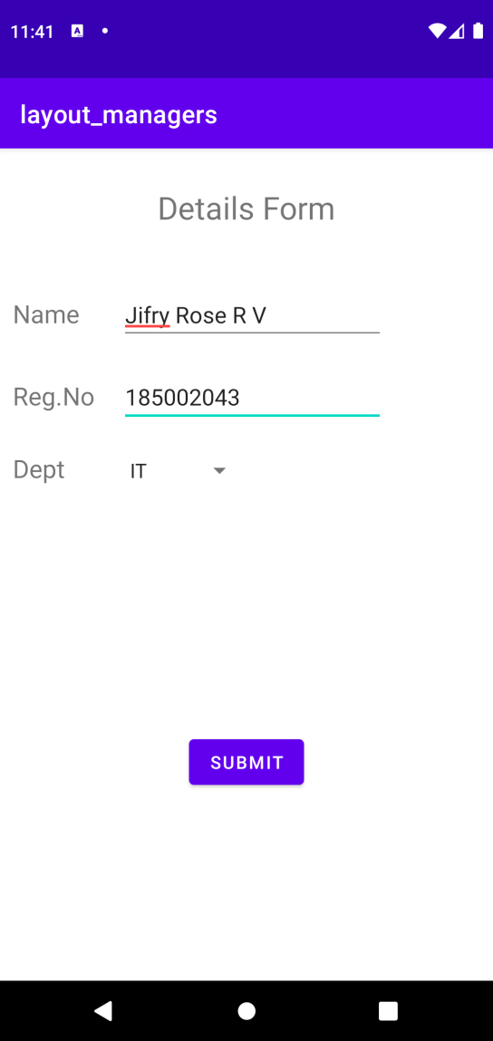

Result:
Thus a Simple Android Application that uses Layout Managers and Event Listeners is developed and executed successfully.
Simple Calculator Application
Exp No : 3
Date : 18/09/2021

Aim:
To implement a simple calculator in android studio.

Software and Hardware Requirements:
Software:
- Android Studio
- Java
Hardware:
- Preferably 8GB+ RAM Laptop/Desktop

Algorithm:
- Open Android Studio and then click on File -> New -> New project.
- Then type the Application name as “calculator″ and click Next.
- Then select the Empty Activity and click Next.
- Finally click Finish.
- The buttons required to implement the calculator are provided in the xml file.
- The implementation of functions for the respective button clicks are specified in the java file.
- When equal button is pressed the function implementation is done
Code:

Activity_main.xml:
<?xml version="1.0" encoding="utf-8"?>
<androidx.constraintlayout.widget.ConstraintLayout
xmlns:android="http://schemas.android.com/apk/res/android"
xmlns:app="http://schemas.android.com/apk/res-auto"
xmlns:tools="http://schemas.android.com/tools"
android:layout_width="match_parent"
android:layout_height="match_parent"
android:background="#8BC34A"
android:backgroundTint="@android:color/darker_gray"
tools:context=".MainActivity">
<!-- Text View to display our basic heading of "calculator"-->
<TextView
android:layout_width="194dp"
android:layout_height="43dp"
android:layout_marginStart="114dp"
android:layout_marginLeft="114dp"
android:layout_marginTop="58dp"
android:layout_marginEnd="103dp"
android:layout_marginRight="103dp"
android:layout_marginBottom="502dp"
android:scrollbarSize="30dp"
android:text=" Calculator"
android:textAppearance="@style/TextAppearance.AppCompat.Body1"
android:textSize="30dp"
app:layout_constraintBottom_toBottomOf="parent"
app:layout_constraintEnd_toEndOf="parent"
app:layout_constraintStart_toStartOf="parent"
app:layout_constraintTop_toTopOf="parent" />
<!-- Edit Text View to input the values -->
<EditText
android:id="@+id/num1"
android:layout_width="364dp"
android:layout_height="28dp"
android:layout_marginStart="72dp"
android:layout_marginTop="70dp"
android:layout_marginEnd="71dp"
android:layout_marginBottom="416dp"
android:background="@android:color/white"
android:ems="10"
android:hint="Number1(0)"
android:inputType="number"
app:layout_constraintBottom_toBottomOf="parent"
app:layout_constraintEnd_toEndOf="parent"
app:layout_constraintStart_toStartOf="parent"
app:layout_constraintTop_toTopOf="parent" />
<!-- Edit Text View to input 2nd value-->
<EditText
android:id="@+id/num2"
android:layout_width="363dp"
android:layout_height="30dp"
android:layout_marginStart="72dp"
android:layout_marginTop="112dp"
android:layout_marginEnd="71dp"
android:layout_marginBottom="374dp"
android:background="@android:color/white"
android:ems="10"
android:hint="number2(0)"
android:inputType="number"
app:layout_constraintBottom_toBottomOf="parent"
app:layout_constraintEnd_toEndOf="parent"
app:layout_constraintStart_toStartOf="parent"
app:layout_constraintTop_toTopOf="parent" />
<!-- Text View to display result -->
<TextView
android:id="@+id/result"
android:layout_width="356dp"
android:layout_height="71dp"
android:layout_marginStart="41dp"
android:layout_marginTop="151dp"
android:layout_marginEnd="48dp"
android:layout_marginBottom="287dp"
android:background="@android:color/white"
android:text="result"
android:textColorLink="#673AB7"
android:textSize="25sp"
app:layout_constraintBottom_toBottomOf="parent"
app:layout_constraintEnd_toEndOf="parent"
app:layout_constraintStart_toStartOf="parent"
app:layout_constraintTop_toTopOf="parent" />
<!-- A button to perform 'sum' operation -->
<Button
android:id="@+id/sum"
android:layout_width="wrap_content"
android:layout_height="wrap_content"
android:layout_marginStart="16dp"
android:layout_marginTop="292dp"
android:layout_marginEnd="307dp"
android:layout_marginBottom="263dp"
android:backgroundTint="@android:color/holo_red_light"
android:onClick="doSum"
android:text="+"
app:layout_constraintBottom_toBottomOf="parent"
app:layout_constraintEnd_toEndOf="parent"
app:layout_constraintStart_toStartOf="parent"
app:layout_constraintTop_toTopOf="parent" />
<!-- A button to perform subtraction operation. -->
<Button
android:id="@+id/sub"
android:layout_width="wrap_content"
android:layout_height="wrap_content"
android:layout_marginStart="210dp"
android:layout_marginTop="292dp"
android:layout_marginEnd="113dp"
android:layout_marginBottom="263dp"
android:backgroundTint="@android:color/holo_red_light"
android:onClick="doSub"
android:text="-"
app:layout_constraintBottom_toBottomOf="parent"
app:layout_constraintEnd_toEndOf="parent"
app:layout_constraintStart_toStartOf="parent"
app:layout_constraintTop_toTopOf="parent" />
<!-- A button to perform division. -->
<Button
android:id="@+id/div"
android:layout_width="wrap_content"
android:layout_height="wrap_content"
android:layout_marginStart="307dp"
android:layout_marginTop="292dp"
android:layout_marginEnd="16dp"
android:layout_marginBottom="263dp"
android:backgroundTint="@android:color/holo_red_light"
android:onClick="doDiv"
android:text="/"
app:layout_constraintBottom_toBottomOf="parent"
app:layout_constraintEnd_toEndOf="parent"
app:layout_constraintHorizontal_bias="0.0"
app:layout_constraintStart_toStartOf="parent"
app:layout_constraintTop_toTopOf="parent" />
<!-- A button to perform multiplication. -->
<Button
android:id="@+id/mul"
android:layout_width="wrap_content"
android:layout_height="wrap_content"
android:layout_marginStart="16dp"
android:layout_marginTop="356dp"
android:layout_marginEnd="307dp"
android:layout_marginBottom="199dp"
android:backgroundTint="@android:color/holo_red_light"
android:onClick="doMul"
android:text="x"
app:layout_constraintBottom_toBottomOf="parent"
app:layout_constraintEnd_toEndOf="parent"
app:layout_constraintStart_toStartOf="parent"
app:layout_constraintTop_toTopOf="parent" />
<!-- A button to perform a modulus function. -->
<Button
android:id="@+id/button"
android:layout_width="92dp"
android:layout_height="48dp"
android:layout_marginStart="113dp"
android:layout_marginTop="356dp"
android:layout_marginEnd="206dp"
android:layout_marginBottom="199dp"
android:backgroundTint="@android:color/holo_red_light"
android:onClick="doMod"
android:text="%(mod)"
app:layout_constraintBottom_toBottomOf="parent"
app:layout_constraintEnd_toEndOf="parent"
app:layout_constraintStart_toStartOf="parent"
app:layout_constraintTop_toTopOf="parent" />
<!-- A button to perform a power function. -->
<Button
android:id="@+id/pow"
android:layout_width="wrap_content"
android:layout_height="wrap_content"
android:layout_marginStart="113dp"
android:layout_marginTop="292dp"
android:layout_marginEnd="210dp"
android:layout_marginBottom="263dp"
android:backgroundTint="@android:color/holo_red_light"
android:onClick="doPow"
android:text="n1^n2"
app:layout_constraintBottom_toBottomOf="parent"
app:layout_constraintEnd_toEndOf="parent"
app:layout_constraintStart_toStartOf="parent"
app:layout_constraintTop_toTopOf="parent" />
</androidx.constraintlayout.widget.ConstraintLayout>

MainActivity_java:
package com.example.calculator_sdk;
import androidx.appcompat.app.AppCompatActivity;
import android.os.Bundle;
import android.view.View;
import android.widget.EditText;
import android.widget.TextView;
public class MainActivity extends AppCompatActivity {
EditText e1, e2;
TextView t1;
int num1, num2;
@Override
protected void onCreate(Bundle savedInstanceState) {
super.onCreate(savedInstanceState);
setContentView(R.layout.activity_main);
}
// a public method to get the input numbers
public boolean getNumbers() {
// defining the edit text 1 to e1
e1 = (EditText) findViewById(R.id.num1);
// defining the edit text 2 to e2
e2 = (EditText) findViewById(R.id.num2);
// defining the text view to t1
t1 = (TextView) findViewById(R.id.result);
// taking input from text box 1
String s1 = e1.getText().toString();
// taking input from text box 2
String s2 = e2.getText().toString();
// condition to check if box is not empty
if ((s1.equals(null) && s2.equals(null))
|| (s1.equals("") && s2.equals(""))) {
String result = "Please enter a value";
t1.setText(result);
return false;
} else {
// converting string to int.
num1 = Integer.parseInt(s1);
// converting string to int.
num2 = Integer.parseInt(s2);
}
return true;
}
// a public method to perform addition
public void doSum(View v) {
// get the input numbers
if (getNumbers()) {
int sum = num1 + num2;
t1.setText(Integer.toString(sum));
}
}
// a public method to perform power function
public void doPow(View v) {
// get the input numbers
if (getNumbers()) {
double sum = Math.pow(num1, num2);
t1.setText(Double.toString(sum));
}
}
// a public method to perform subtraction
public void doSub(View v) {
// get the input numbers
if (getNumbers()) {
int sum = num1 - num2;
t1.setText(Integer.toString(sum));
}
}
// a public method to perform multiplication
public void doMul(View v) {
// get the input numbers
if (getNumbers()) {
int sum = num1 * num2;
t1.setText(Integer.toString(sum));
}
}
// a public method to perform Division
public void doDiv(View v) {
// get the input numbers
if (getNumbers()) {
// displaying the text in text view assigned as t1
double sum = num1 / (num2 * 1.0);
t1.setText(Double.toString(sum));
}
}
// a public method to perform modulus function
public void doMod(View v) {
// get the input numbers
if (getNumbers()) {
double sum = num1 % num2;
t1.setText(Double.toString(sum));
}
}
}

Sample I/O:

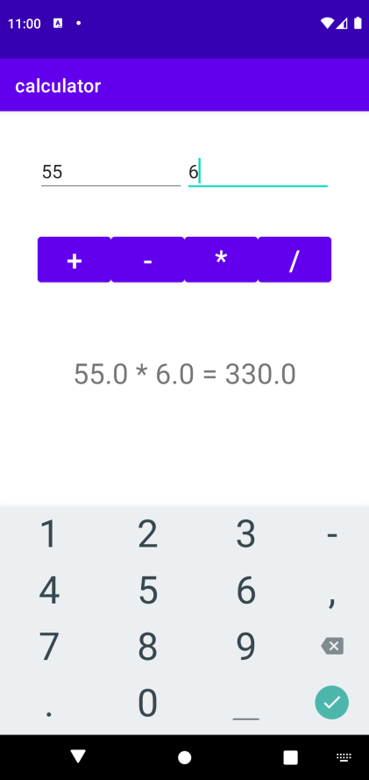

Result:
Thus a Simple Android Application for Native Calculator is developed and executed successfully.
Basic Graphical Primitives
Expt. No: 04
Date: 20/09/2021

Aim:
To implement basic graphical primitives in android studio.

Software and Hardware Requirements:
Software:
- Android Studio
- Java
Hardware:
- Preferably 8GB+ RAM Laptop/Desktop

Algorithm:
1. Open Android Studio and create a new project.
2. Select Empty Activity.
3. Android provides a huge set of 2D-drawing APIs that allow you to create graphics.
4. The Bitmap (android.graphics.Bitmap) class represents a bitmap image.
5. A Canvas is an object that you can draw on by calling drawing commands. In this program, we have drawn a rectangle, circle, square and line using Canvas class.

Code:
Activity_main.xml:
<?xml version="1.0" encoding="utf-8"?>
<RelativeLayout xmlns:android="http://schemas.android.com/apk/res/android"
android:layout_width="match_parent"
android:layout_height="match_parent">
<ImageView
android:layout_width="match_parent"
android:layout_height="match_parent"
android:id="@+id/imageView" />
</RelativeLayout>

MainActivity.java:
package com.example.graphicalapplication;
import android.os.Bundle;
import android.app.Activity;
import android.graphics.Bitmap;
import android.graphics.Canvas;
import android.graphics.Color;
import android.graphics.Paint;
import android.graphics.drawable.BitmapDrawable;
import android.widget.ImageView;
public class MainActivity extends Activity
{
@Override
public void onCreate(Bundle savedInstanceState)
{
super.onCreate(savedInstanceState);
setContentView(R.layout.activity_main);
//Creating a Bitmap
Bitmap bg = Bitmap.createBitmap(720, 1280, Bitmap.Config.ARGB_8888);
//Setting the Bitmap as background for the ImageView
ImageView i = (ImageView) findViewById(R.id.imageView);
i.setBackgroundDrawable(new BitmapDrawable(bg));
//Creating the Canvas Object
Canvas canvas = new Canvas(bg);
//Creating the Paint Object and set its color & TextSize
Paint paint = new Paint();
paint.setColor(Color.RED);
paint.setTextSize(50);
//To draw a Rectangle
canvas.drawText("Rectangle", 420, 150, paint);
canvas.drawRect(400, 200, 650, 700, paint);
//To draw a Circle
canvas.drawText("Circle", 120, 150, paint);
canvas.drawCircle(200, 350, 150, paint);
//To draw a Square
canvas.drawText("Square", 120, 800, paint);
canvas.drawRect(50, 850, 350, 1150, paint);
//To draw a Line
canvas.drawText("Line", 480, 800, paint);
canvas.drawLine(520, 850, 520, 1150, paint);
}
}

Sample I/O:

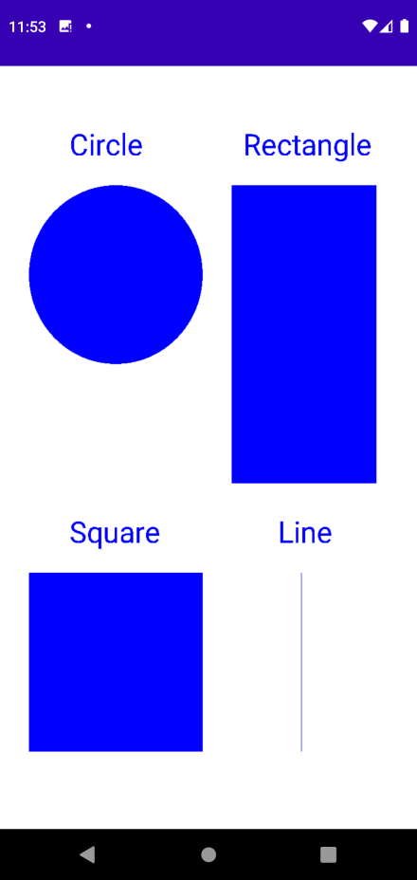

Result:
Thus a Simple Android Application that draws basic Graphical Primitives on the screen is developed and executed successfully.

Database
Expt. No: 05
Date: 25/09/2021

Aim:
To develop a simple Android Application using a database.

Software and Hardware Requirements:
Software:
1. Android Studio
2. Java
Hardware:
1. Preferably 8GB+ RAM Laptop/Desktop

Algorithm:
1. Open Android Studio and create a new project.
2. Select Empty Activity.
3. SQLiteDatabase has methods to create, delete, execute SQL commands, and perform other common database management tasks.
4. The Builder class has several methods. This program makes use of the following:
· setCancelable(boolean flag): Sets whether this dialog is cancelable with the BACK key.
· setTitle(char Sequence): Makes the string passed as the title.
5. Event Listeners are used to track mouse clicks

Code:

MainActivity.java
package com.example.database;

import android.os.Bundle;

import android.app.Activity;
import android.app.AlertDialog.Builder;
import android.content.Context;
import android.database.Cursor;
import android.database.sqlite.SQLiteDatabase;

import android.os.Bundle;
import android.view.View;
import android.view.View.OnClickListener;
import android.widget.Button;
import android.widget.EditText;

public class MainActivity extends Activity implements OnClickListener
{
EditText Rollno,Name,Marks;
Button Insert,Delete,Update,View,ViewAll;
SQLiteDatabase db;
/** Called when the activity is first created. */
@Override
public void onCreate(Bundle savedInstanceState)
{
super.onCreate(savedInstanceState);
setContentView(R.layout.activity_main);

Rollno=(EditText)findViewById(R.id.Rollno);
Name=(EditText)findViewById(R.id.Name);
Marks=(EditText)findViewById(R.id.Marks);
Insert=(Button)findViewById(R.id.Insert);
Delete=(Button)findViewById(R.id.Delete);
Update=(Button)findViewById(R.id.Update);
View=(Button)findViewById(R.id.View);
ViewAll=(Button)findViewById(R.id.ViewAll);

Insert.setOnClickListener(this);
Delete.setOnClickListener(this);
Update.setOnClickListener(this);
View.setOnClickListener(this);
ViewAll.setOnClickListener(this);

// Creating database and table
db=openOrCreateDatabase("StudentDB", Context.MODE_PRIVATE, null);
db.execSQL("CREATE TABLE IF NOT EXISTS student(rollno VARCHAR,name VARCHAR,marks VARCHAR);");
}
public void onClick(View view)
{
// Inserting a record to the Student table
if(view==Insert)
{
// Checking for empty fields
if(Rollno.getText().toString().trim().length()==0||
Name.getText().toString().trim().length()==0||
Marks.getText().toString().trim().length()==0)
{
showMessage("Error", "Please enter all values");
return;
}
db.execSQL("INSERT INTO student VALUES('"+Rollno.getText()+"','"+Name.getText()+
"','"+Marks.getText()+"');");
showMessage("Success", "Record added");
clearText();
}
// Deleting a record from the Student table
if(view==Delete)
{
// Checking for empty roll number
if(Rollno.getText().toString().trim().length()==0)
{
showMessage("Error", "Please enter Rollno");
return;
}
Cursor c=db.rawQuery("SELECT * FROM student WHERE rollno='"+Rollno.getText()+"'", null);
if(c.moveToFirst())
{
db.execSQL("DELETE FROM student WHERE rollno='"+Rollno.getText()+"'");
showMessage("Success", "Record Deleted");
}
else
{
showMessage("Error", "Invalid Rollno");
}
clearText();
}
// Updating a record in the Student table
if(view==Update)
{
// Checking for empty roll number
if(Rollno.getText().toString().trim().length()==0)
{
showMessage("Error", "Please enter Rollno");
return;
}
Cursor c=db.rawQuery("SELECT * FROM student WHERE rollno='"+Rollno.getText()+"'", null);
if(c.moveToFirst()) {
db.execSQL("UPDATE student SET name='" + Name.getText() + "',marks='" + Marks.getText() +
"' WHERE rollno='"+Rollno.getText()+"'");
showMessage("Success", "Record Modified");
}
else {
showMessage("Error", "Invalid Rollno");
}
clearText();
}
// Display a record from the Student table
if(view==View)
{
// Checking for empty roll number
if(Rollno.getText().toString().trim().length()==0)
{
showMessage("Error", "Please enter Rollno");
return;
}
Cursor c=db.rawQuery("SELECT * FROM student WHERE rollno='"+Rollno.getText()+"'", null);
if(c.moveToFirst())
{
Name.setText(c.getString(1));
Marks.setText(c.getString(2));
}
else
{
showMessage("Error", "Invalid Rollno");
clearText();
}
}
// Displaying all the records
if(view==ViewAll)
{
Cursor c=db.rawQuery("SELECT * FROM student", null);
if(c.getCount()==0)
{
showMessage("Error", "No records found");
return;
}
StringBuffer buffer=new StringBuffer();
while(c.moveToNext())
{
buffer.append("Rollno: "+c.getString(0)+"\n");
buffer.append("Name: "+c.getString(1)+"\n");
buffer.append("Marks: "+c.getString(2)+"\n\n");
}
showMessage("Student Details", buffer.toString());
}
}
public void showMessage(String title,String message)
{
Builder builder=new Builder(this);
builder.setCancelable(true);
builder.setTitle(title);
builder.setMessage(message);
builder.show();
}
public void clearText()
{
Rollno.setText("");
Name.setText("");
Marks.setText("");
Rollno.requestFocus();
}
}

activity_main.xml:
<?xml version="1.0" encoding="utf-8"?>
<AbsoluteLayout xmlns:android="http://schemas.android.com/apk/res/android"
android:layout_width="match_parent"
android:layout_height="match_parent">
<TextView
android:layout_width="wrap_content"
android:layout_height="wrap_content"
android:layout_x="50dp"
android:layout_y="20dp"
android:text="Student Details"
android:textSize="30sp" />

<TextView
android:layout_width="wrap_content"
android:layout_height="wrap_content"
android:layout_x="20dp"
android:layout_y="110dp"
android:text="Enter Rollno:"
android:textSize="20sp" />

<EditText
android:id="@+id/Rollno"
android:layout_width="150dp"
android:layout_height="wrap_content"
android:layout_x="175dp"
android:layout_y="100dp"
android:inputType="number"
android:textSize="20sp" />

<TextView
android:layout_width="wrap_content"
android:layout_height="wrap_content"
android:layout_x="20dp"
android:layout_y="160dp"
android:text="Enter Name:"
android:textSize="20sp" />

<EditText
android:id="@+id/Name"
android:layout_width="150dp"
android:layout_height="wrap_content"
android:layout_x="175dp"
android:layout_y="150dp"
android:inputType="text"
android:textSize="20sp" />

<TextView
android:layout_width="wrap_content"
android:layout_height="wrap_content"
android:layout_x="20dp"
android:layout_y="210dp"
android:text="Enter Marks:"
android:textSize="20sp" />

<EditText
android:id="@+id/Marks"
android:layout_width="150dp"
android:layout_height="wrap_content"
android:layout_x="175dp"
android:layout_y="200dp"
android:inputType="number"
android:textSize="20sp" />

<Button
android:id="@+id/Insert"
android:layout_width="150dp"
android:layout_height="wrap_content"
android:layout_x="25dp"
android:layout_y="300dp"
android:text="Insert"
android:textSize="30dp" />

<Button
android:id="@+id/Delete"
android:layout_width="150dp"
android:layout_height="wrap_content"
android:layout_x="200dp"
android:layout_y="300dp"
android:text="Delete"
android:textSize="30dp" />

<Button
android:id="@+id/Update"
android:layout_width="150dp"
android:layout_height="wrap_content"
android:layout_x="25dp"
android:layout_y="400dp"
android:text="Update"
android:textSize="30dp" />

<Button
android:id="@+id/View"
android:layout_width="150dp"
android:layout_height="wrap_content"
android:layout_x="200dp"
android:layout_y="400dp"
android:text="View"
android:textSize="30dp" />

<Button
android:id="@+id/ViewAll"
android:layout_width="200dp"
android:layout_height="wrap_content"
android:layout_x="100dp"
android:layout_y="500dp"
android:text="View All"
android:textSize="30dp" />

</AbsoluteLayout>

Sample I/O:

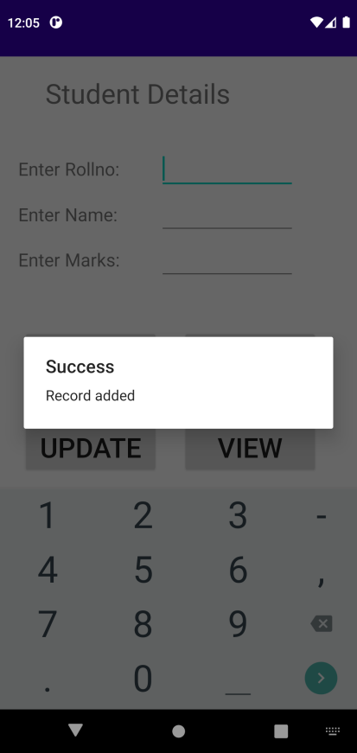

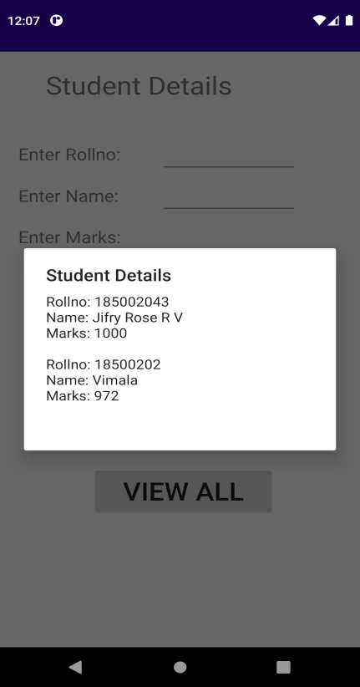
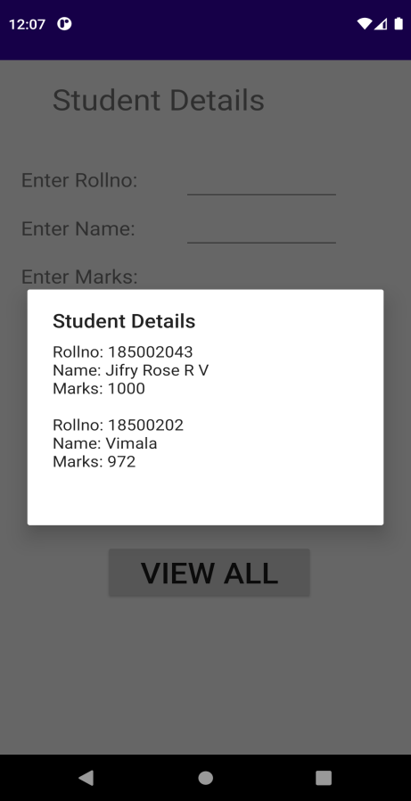

Result:
Thus, a simple application using a database has been successfully implemented using android studio.

Multithreading
Expt.No:06
Date:27/092021

Aim:
To develop an Android Application that implements Multithreading.

Software and Hardware Requirements:
Software:
1. Android Studio
2. Java
Hardware:
1. Preferably 8GB+ RAM Laptop/Desktop

Algorithm:
- A thread is a thread of execution in a program. The Java Virtual Machine allows an application to have multiple threads of execution running concurrently.
- When a Java Virtual Machine starts up, there is usually a single non-daemon thread (which typically calls the method named main of some designated class). The Java Virtual Machine continues to execute threads until either of the following occurs:
    - · The exit method of class Runtime has been called and the security manager has permitted the exit operation to take place.
    - · All threads that are not daemon threads have died, either by returning from the call to the run method or by throwing an exception that propagates beyond the run method.
- Using the runnable instance of the thread module, we multi-thread the process of loading two images of the India map.
- On selecting the first button, one type of image will be displayed and on selecting the other button, the second image will be displayed immediately

Code:
MainActivity.java:

package com.example.multithreading;

import android.os.Bundle;
import androidx.appcompat.app.AppCompatActivity;
import android.view.View;
import android.widget.Button;
import android.widget.ImageView;
public class MainActivity extends AppCompatActivity
{
ImageView img;
Button bt1,bt2;
@Override
protected void onCreate(Bundle savedInstanceState)
{
super.onCreate(savedInstanceState);
setContentView(R.layout.activity_main);

bt1 = (Button)findViewById(R.id.button);
bt2= (Button) findViewById(R.id.button2);
img = (ImageView)findViewById(R.id.imageView);

bt1.setOnClickListener(new View.OnClickListener()
{
@Override
public void onClick(View v)
{
new Thread(new Runnable()
{
@Override
public void run()
{
img.post(new Runnable()
{
@Override
public void run()
{
img.setImageResource(R.drawable.pic1);
}
});
}
}).start();
}
});

bt2.setOnClickListener(new View.OnClickListener()
{
@Override
public void onClick(View v)
{
new Thread(new Runnable()
{
@Override
public void run()
{
img.post(new Runnable()
{
@Override
public void run()
{
img.setImageResource(R.drawable.pic2);
}
});
}
}).start();
}
});
}
}

activitymain.xml:
<?xml version="1.0" encoding="utf-8"?>
<LinearLayout xmlns:android="http://schemas.android.com/apk/res/android"
android:layout_width="match_parent"
android:layout_height="match_parent"
android:orientation="vertical" >

<ImageView
android:id="@+id/imageView"
android:layout_width="250dp"
android:layout_height="250dp"
android:layout_margin="50dp"
android:layout_gravity="center" />

<Button
android:id="@+id/button"
android:layout_width="wrap_content"
android:layout_height="wrap_content"
android:layout_margin="5dp"
android:layout_gravity="center"
android:text="Load Image 1" />

<Button
android:id="@+id/button2"
android:layout_width="wrap_content"
android:layout_height="wrap_content"
android:layout_margin="5dp"
android:layout_gravity="center"
android:text="Load image 2" />

</LinearLayout>

Sample I/O:

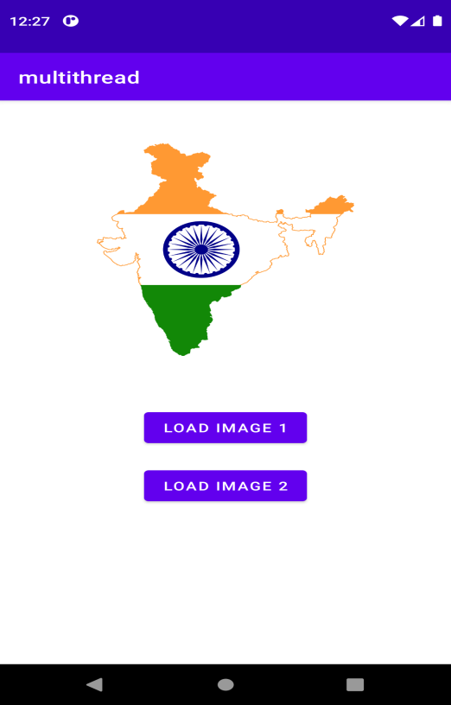

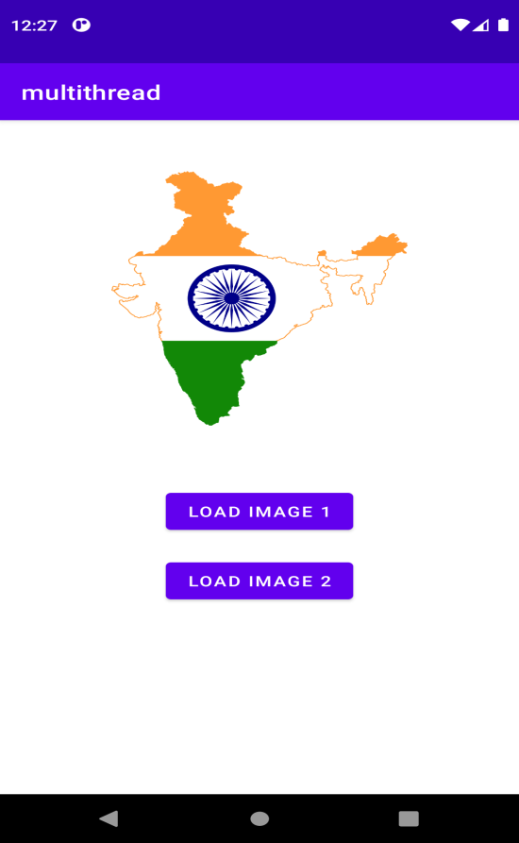

Result:
Thus, an Android Application that implements Multithreading has been successfully implemented.
SD Card
Expt. No:07
Date:04/10/2021

Aim:
To develop an Android Application that writes data to the SD Card.

Algorithm:
1. Create a new flutter project
2. Create a text field with a controller.
3. Create a button, that when pressed, saved the text written on the text field to the sd card.
4. Get directory path from path provider package
5. Write the contents to the preferred file.

Code:
activity_main.xml:

<?xml version="1.0" encoding="utf-8"?>
<androidx.constraintlayout.widget.ConstraintLayout xmlns:android="http://schemas.android.com/apk/res/android"
xmlns:app="http://schemas.android.com/apk/res-auto"
xmlns:tools="http://schemas.android.com/tools"
android:layout_width="match_parent"
android:layout_height="match_parent"
tools:context=".MainActivity">
<TextView
android:id="@+id/title"
android:layout_width="wrap_content"
android:layout_height="wrap_content"
android:text="SD Card App"
android:textAppearance="@style/TextAppearance.AppCompat.Display1"
android:textColor="#007565"
app:layout_constraintBottom_toBottomOf="parent"
app:layout_constraintHorizontal_bias="0.497"
app:layout_constraintLeft_toLeftOf="parent"
app:layout_constraintRight_toRightOf="parent"
app:layout_constraintTop_toTopOf="parent"
app:layout_constraintVertical_bias="0.064" />
<TextView
android:id="@+id/textView"
android:layout_width="wrap_content"
android:layout_height="wrap_content"
android:layout_marginTop="36dp"
android:layout_marginEnd="108dp"
android:text="Write contents into a file"
android:textAppearance="@style/TextAppearance.AppCompat.Medium"
android:textColor="#00BFA5"
app:layout_constraintEnd_toEndOf="parent"
app:layout_constraintTop_toBottomOf="@+id/title"
android:layout_marginRight="108dp" />
<TextView
android:id="@+id/textView2"
android:layout_width="wrap_content"
android:layout_height="wrap_content"
android:layout_marginTop="80dp"
android:layout_marginEnd="150dp"
android:text="File contents:"
android:textAppearance="@style/TextAppearance.AppCompat.Medium"
android:textColor="#304FFE"
app:layout_constraintEnd_toEndOf="parent"
app:layout_constraintTop_toBottomOf="@+id/title"
android:layout_marginRight="152dp" />
<TextView
android:id="@+id/textView3"
android:layout_width="wrap_content"
android:layout_height="wrap_content"
android:layout_marginTop="180dp"
android:layout_marginEnd="150dp"
android:text="File Name:"
android:textAppearance="@style/TextAppearance.AppCompat.Medium"
android:textColor="#304FFE"
app:layout_constraintEnd_toEndOf="parent"
app:layout_constraintTop_toBottomOf="@+id/title"
android:layout_marginRight="256dp" />
<EditText
android:id="@+id/content"
android:layout_width="166dp"
android:layout_height="44dp"
android:layout_marginTop="10dp"
android:layout_marginEnd="40dp"
android:ems="10"
android:gravity="start|top"
android:inputType="textMultiLine"
app:layout_constraintEnd_toEndOf="parent"
app:layout_constraintTop_toBottomOf="@+id/textView2"
android:layout_marginRight="40dp" />
<EditText
android:id="@+id/filename"
android:layout_width="163dp"
android:layout_height="44dp"
android:layout_marginTop="80dp"
android:layout_marginEnd="60dp"
android:ems="10"
android:gravity="start|top"
android:inputType="textMultiLine"
app:layout_constraintEnd_toEndOf="parent"
app:layout_constraintTop_toBottomOf="@+id/textView2"
android:layout_marginRight="60dp" />
<Button
android:id="@+id/writebtn"
android:layout_width="wrap_content"
android:layout_height="wrap_content"
android:layout_marginTop="32dp"
android:layout_marginEnd="156dp"
android:backgroundTint="#00BFA5"
android:text="Write File"
app:layout_constraintEnd_toEndOf="parent"
app:layout_constraintTop_toBottomOf="@+id/filename"
android:layout_marginRight="156dp" />
<Button
android:id="@+id/btnLoad"
android:layout_width="wrap_content"
android:layout_height="wrap_content"
android:layout_marginTop="100dp"
android:layout_marginEnd="136dp"
android:backgroundTint="#00BFA5"
android:text="Load From File"
app:layout_constraintEnd_toEndOf="parent"
app:layout_constraintTop_toBottomOf="@+id/filename"
android:layout_marginRight="136dp" />
</androidx.constraintlayout.widget.ConstraintLayout>

activity_read.xml:
<?xml version="1.0" encoding="utf-8"?>
<androidx.constraintlayout.widget.ConstraintLayout xmlns:android="http://schemas.android.com/apk/res/android"
xmlns:app="http://schemas.android.com/apk/res-auto"
xmlns:tools="http://schemas.android.com/tools"
android:layout_width="match_parent"
android:layout_height="match_parent"
tools:context=".ReadFile">
<EditText
android:id="@+id/filename2"
android:layout_width="163dp"
android:layout_height="40dp"
android:layout_marginTop="28dp"
android:layout_marginEnd="52dp"
android:ems="10"
android:gravity="start|top"
android:inputType="textMultiLine"
app:layout_constraintEnd_toEndOf="parent"
app:layout_constraintTop_toBottomOf="@+id/textView6"
android:layout_marginRight="52dp" />
<TextView
android:id="@+id/textView4"
android:layout_width="wrap_content"
android:layout_height="wrap_content"
android:layout_marginTop="40dp"
android:layout_marginEnd="152dp"
android:text="File contents:"
android:textAppearance="@style/TextAppearance.AppCompat.Medium"
android:textColor="#304FFE"
app:layout_constraintEnd_toEndOf="parent"
app:layout_constraintTop_toBottomOf="@+id/loadbtn"
android:layout_marginRight="152dp" />
<TextView
android:id="@+id/title2"
android:layout_width="wrap_content"
android:layout_height="wrap_content"
android:layout_marginTop="44dp"
android:layout_marginEnd="108dp"
android:text="SD Card App"
android:textAppearance="@style/TextAppearance.AppCompat.Display1"
android:textColor="#007565"
app:layout_constraintEnd_toEndOf="parent"
app:layout_constraintTop_toTopOf="parent"
android:layout_marginRight="108dp" />
<TextView
android:id="@+id/textView5"
android:layout_width="wrap_content"
android:layout_height="wrap_content"
android:layout_marginStart="100dp"
android:layout_marginTop="28dp"
android:text="File Name:"
android:textAppearance="@style/TextAppearance.AppCompat.Medium"
android:textColor="#304FFE"
app:layout_constraintStart_toStartOf="parent"
app:layout_constraintTop_toBottomOf="@+id/textView6"
android:layout_marginLeft="100dp" />
<Button
android:id="@+id/loadbtn"
android:layout_width="wrap_content"
android:layout_height="wrap_content"
android:layout_marginTop="36dp"
android:layout_marginEnd="148dp"
android:backgroundTint="#00BFA5"
android:text="LOAD FILE"
app:layout_constraintEnd_toEndOf="parent"
app:layout_constraintTop_toBottomOf="@+id/filename2"
android:layout_marginRight="148dp" />
<TextView
android:id="@+id/textView6"
android:layout_width="wrap_content"
android:layout_height="wrap_content"
android:layout_marginTop="20dp"
android:layout_marginEnd="104dp"
android:text="Read contents From File"
android:textAppearance="@style/TextAppearance.AppCompat.Medium"
android:textColor="#00BFA5"
app:layout_constraintEnd_toEndOf="parent"
app:layout_constraintTop_toBottomOf="@+id/title2"
android:layout_marginRight="104dp" />
<TextView
android:id="@+id/tvLoad"
android:layout_width="283dp"
android:layout_height="116dp"
android:layout_marginTop="32dp"
android:layout_marginEnd="52dp"
android:textAppearance="@style/TextAppearance.AppCompat.Body1"
app:layout_constraintEnd_toEndOf="parent"
app:layout_constraintTop_toBottomOf="@+id/textView4"
android:layout_marginRight="52dp" />
</androidx.constraintlayout.widget.ConstraintLayout>

MainActivity.java:
import androidx.appcompat.app.AppCompatActivity;
import androidx.core.app.ActivityCompat;
import android.content.DialogInterface;
import android.content.Intent;
import android.content.pm.PackageManager;
import android.os.Build;
import android.os.Bundle;
import android.os.Environment;
import android.view.View;
import android.widget.Button;
import android.widget.EditText;
import android.widget.TextView;
import android.widget.Toast;

import java.io.BufferedReader;
import java.io.File;
import java.io.FileNotFoundException;
import java.io.FileOutputStream;
import java.io.FileReader;
import java.io.IOException;
import java.io.OutputStreamWriter;

import androidx.appcompat.app.AppCompatActivity;
import androidx.core.app.ActivityCompat;
import android.content.DialogInterface;
import android.content.Intent;
import android.content.pm.PackageManager;
import android.os.Build;
import android.os.Bundle;
import android.os.Environment;
import android.view.View;
import android.widget.Button;
import android.widget.EditText;
import android.widget.TextView;
import android.widget.Toast;
import java.io.BufferedReader;
import java.io.File;
import java.io.FileNotFoundException;
import java.io.FileOutputStream;
import java.io.FileReader;
import java.io.IOException;
import java.io.OutputStreamWriter;

public class MainActivity extends AppCompatActivity {
// Declare the View object references
Button btnSave, btnLoad;
EditText content, filenamev;
TextView tvLoad;
// Define some String variables, initialized with empty string

String filepath = "";
String filename = "";
String fileContent = "";

@Override
protected void onCreate(Bundle savedInstanceState) {
super.onCreate(savedInstanceState);
setContentView(R.layout.activity_main);
btnSave = findViewById(R.id.writebtn);
btnLoad = findViewById(R.id.btnLoad);
content = findViewById(R.id.content);
filenamev = findViewById(R.id.filename);
filepath = "NewDirectory";

if(!isExternalStorageAvailableForRW()){
btnSave.setEnabled(false);
}

btnSave.setOnClickListener(new View.OnClickListener() {
@Override
public void onClick(View view) {

fileContent = content.getText().toString().trim();
filename = filenamev.getText().toString().trim();

// Check for Storage Permission
if(isStoragePermissionGranted()){

if(!fileContent.equals("")){
File myExternalFile = new File(getExternalFilesDir(filepath), filename);
FileOutputStream fos = null;
try {
fos = new FileOutputStream(myExternalFile);
fos.write(fileContent.getBytes());
fos.close();
} catch (FileNotFoundException e) {
e.printStackTrace();
} catch (IOException e) {
e.printStackTrace();
}

content.setText("");
filenamev.setText("");
// Show a Toast message to inform the user that the operation has been successfully completed.
Toast.makeText(MainActivity.this, "File saved to SD card.", Toast.LENGTH_SHORT).show();
} else{
// If the Text field is empty show corresponding Toast message
Toast.makeText(MainActivity.this, "Text field can not be empty.", Toast.LENGTH_SHORT).show();
}
}

}
});

btnLoad.setOnClickListener(new View.OnClickListener() {
@Override
public void onClick(View view) {
Intent myIntent = new Intent(MainActivity.this, ReadFile.class);
MainActivity.this.startActivity(myIntent);
}
});
}

public boolean isStoragePermissionGranted() {
if (Build.VERSION.SDK_INT >= Build.VERSION_CODES.M) {
if (checkSelfPermission(android.Manifest.permission.WRITE_EXTERNAL_STORAGE)
== PackageManager.PERMISSION_GRANTED) {
//Permission is granted
return true;
} else {
//Permission is revoked
ActivityCompat.requestPermissions(this, new String[]{android.Manifest.permission.WRITE_EXTERNAL_STORAGE}, 1);
return false;
}
}
else {
//permission is automatically granted on sdk<23 upon installation
//Permission is granted
return true;
}
}

private boolean isExternalStorageAvailableForRW() {
// Check if the external storage is available for read and write by calling
// Environment.getExternalStorageState() method. If the returned state is MEDIA_MOUNTED,
// then you can read and write files. So, return true in that case, otherwise, false.
String extStorageState = Environment.getExternalStorageState();
if(extStorageState.equals(Environment.MEDIA_MOUNTED)){
return true;
}
return false;
}
}

ReadFile.java:
package com.example.sd;

import androidx.appcompat.app.AppCompatActivity;

import android.os.Bundle;

import android.view.View;

import android.widget.Button;

import android.widget.EditText;

import android.widget.TextView;

import java.io.BufferedReader;

import java.io.File;

import java.io.FileNotFoundException;

import java.io.FileReader;

import java.io.IOException;

public class ReadFile extends AppCompatActivity {

Button btnLoad;

TextView tvLoad;

EditText filenamev;

String filename = "";

String filepath = "NewDirectory";

@Override

protected void onCreate(Bundle savedInstanceState) {

super.onCreate(savedInstanceState);

setContentView(R.layout.activity_read_file);

btnLoad = findViewById(R.id.loadbtn);

filenamev = findViewById(R.id.filename2);

tvLoad = findViewById(R.id.tvLoad);
btnLoad.setOnClickListener(new View.OnClickListener() {

@Override
public void onClick(View view) {

filename = filenamev.getText().toString().trim();

FileReader fr = null;

File myExternalFile = new File(getExternalFilesDir(filepath), filename);

StringBuilder stringBuilder = new StringBuilder();

try {

fr = new FileReader(myExternalFile);
BufferedReader br = new BufferedReader(fr);

String line = br.readLine();

while(line != null){

stringBuilder.append(line).append('\n');

line = br.readLine();

}

} catch (FileNotFoundException e) {

e.printStackTrace();

} catch (IOException e) {

e.printStackTrace();
} finally {

String fileContents = stringBuilder.toString();

tvLoad.setText(fileContents);

}

}

});

}

}

AndroidManifest.xml:

<?xml version="1.0" encoding="utf-8"?>

<manifest xmlns:android="http://schemas.android.com/apk/res/android"

package="com.example.sd">

<uses-permission android:name="android.permission.WRITE_EXTERNAL_STORAGE" />

<uses-permission android:name="android.permission.READ_EXTERNAL_STORAGE" />

<application

android:allowBackup="true"

android:icon="@mipmap/ic_launcher"

android:label="@string/app_name"

android:roundIcon="@mipmap/ic_launcher_round"

android:supportsRtl="true"

android:theme="@style/Theme.Sd">

<activity

android:name=".ReadFile"

android:exported="true" />

<activity

android:name=".MainActivity"

android:exported="true">

<intent-filter>

<action android:name="android.intent.action.MAIN" />

<category android:name="android.intent.category.LAUNCHER" />

</intent-filter>

</activity>

</application>

</manifest>

themes.xml:
<resources xmlns:tools="http://schemas.android.com/tools">

<!-- Base application theme. -->

<style name="Theme.Sd" parent="Theme.MaterialComponents.DayNight.DarkActionBar">

<!-- Primary brand color. -->

<item name="colorPrimary">@color/purple_500</item>

<item name="colorPrimaryVariant">@color/purple_700</item>

<item name="colorOnPrimary">@color/white</item>

<!-- Secondary brand color. -->

<item name="colorSecondary">@color/teal_200</item>

<item name="colorSecondaryVariant">@color/teal_700</item>

<item name="colorOnSecondary">@color/black</item>

<!-- Status bar color. -->

<item name="android:statusBarColor" tools:targetApi="l">?attr/colorPrimaryVariant</item>

<!-- Customize your theme here. -->

</style>

</resources>

Sample I/O:
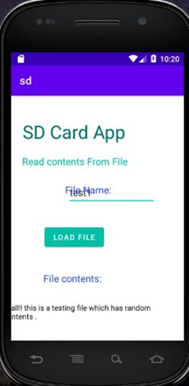
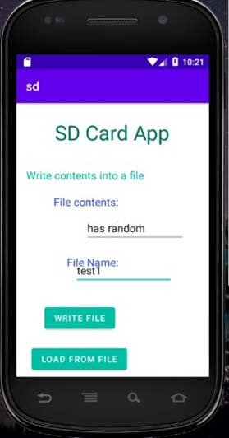

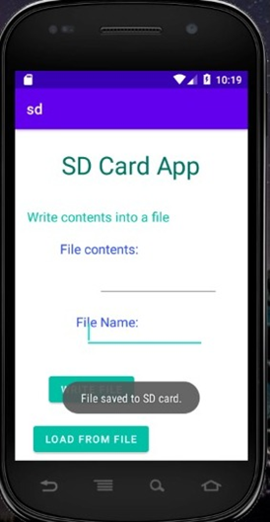

Result:
Thus, an Android Application that writes data to the SD Card was successfully implemented.
Alert
Expt.No:08
Date:11/10/2021

Aim:
To develop an Android Application that creates an alert upon receiving a message.

Software and Hardware Requirements:
Software:
1. Android Studio
2. Java
Hardware:
1. Preferably 8GB+ RAM Laptop/Desktop

Algorithm:
- Open Android Studio and then click on File -> New -> New project.
- Then type the Application name as “alert″ and click Next.
- Then select the Empty Activity and click Next.
- In this application, a java class is created that makes use of BroadCastReceiver and SmsManager to get the sender number of the SMS along with the text that was sent.
- These details are given as a toast message alert when the SMS is received by the device. This application uses the SMS permission to SEND, RECEIVE and READ SMS.

Code:
MainActivity.java:
package com.example.alert;

import android.app.Notification;
import android.app.NotificationManager;
import android.app.PendingIntent;
import android.content.Intent;
import android.os.Bundle;
import android.view.View;
import android.widget.Button;
import android.widget.EditText;

import androidx.appcompat.app.AppCompatActivity;

public class MainActivity extends AppCompatActivity{
Button notify;
EditText e;
@Override

public void onCreate(Bundle savedInstanceState){
super.onCreate(savedInstanceState);
setContentView(R.layout.activity_main);
notify= (Button) findViewById(R.id.button);
e= (EditText) findViewById(R.id.editText);
notify.setOnClickListener(new View.OnClickListener() {
@Override
public void onClick(View v){
Intent intent = new Intent(MainActivity.this, SecondActivity.class);
PendingIntent pending = PendingIntent.getActivity(MainActivity.this, 0, intent, 0);
Notification noti = new Notification.Builder(MainActivity.this).setContentTitle("New Message").setContentText(e.getText().toString()).setSmallIcon(R.mipmap.ic_launcher).setContentIntent(pending).build();
NotificationManager manager = (NotificationManager) getSystemService(NOTIFICATION_SERVICE);
noti.flags |= Notification.FLAG_AUTO_CANCEL;
manager.notify(0, noti);
}
});
}
}
Activity_main.xml:
<?xml version="1.0" encoding="utf-8"?>
<LinearLayout xmlns:android="http://schemas.android.com/apk/res/android"
android:layout_width="match_parent"
android:layout_height="match_parent"
android:layout_margin="10dp"
android:orientation="vertical">

<TextView
android:layout_width="wrap_content"
android:layout_height="wrap_content"
android:text="Message"
android:textSize="30sp" />

<EditText
android:id="@+id/editText"
android:layout_width="match_parent"
android:layout_height="wrap_content"
android:singleLine="true"
android:textSize="30sp" />
<Button
android:id="@+id/button"
android:layout_width="wrap_content"
android:layout_height="wrap_content"
android:layout_margin="30dp"
android:layout_gravity="center"
android:text="Notify"
android:textSize="30sp"/>
</LinearLayout>

OUTPUT:
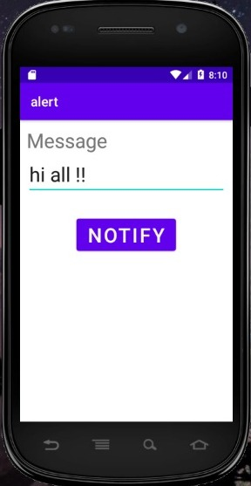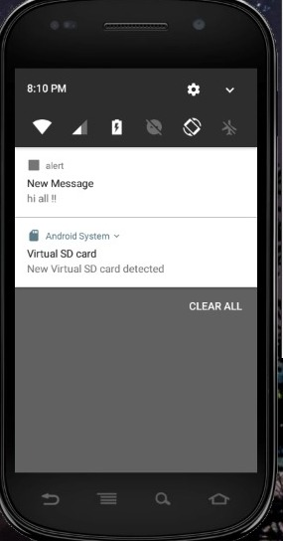

RESULT:
Thus Android Application that creates an alert upon receiving a message is developed and executed successfully.

Alarm
Expt.No:09
Date:18/10/2021

Aim:
To develop an Android Application that creates an alert upon receiving a message.
Software and Hardware Requirements:
Software:
1. Android Studio
2. Java
Hardware:
1. Preferably 8GB+ RAM Laptop/Desktop

Algorithm:
1) Open Android Studio and then click on File -> New -> New project.
2) Then type the Application name as “alert″ and click Next.
3) Then select the Empty Activity and click Next.
4) In the xml file, we have added two items ‘TimePicker’ and ‘ToggleButton’. TimePicker is used to capture the alarm time and ToggleButton is added to set the alarm on or off.
5) In MainActivity.java class the onToggleClicked( ) method is implemented in which the current hour and the minute is set using the calendar.
- Create a new java class named “AlarmReceiver.java” at the same place where MainActivity.java class resides. In this class the onReceive() method is implemented. Here we have added vibration functionality and a default ringtone that starts to vibrate and ring when the alarm time is scheduled.
- Go to the “values” folder first then choose the colors.xml file. In the colors.xml file, you can keep colors of your choice as many as you want to use in your app.
- Go to the “values” folder first then choose the themes.xml file. In the theme.xml file, we have used “Theme.AppCompat.Light.DarkActionBar” which is a light theme with a dark ActionBar
- Go to the “AndroidManifest.xml” file. A BroadcastReceiver is registered in AndroidManifest.xml by adding a receiver section after the application section is over.

Code:
MainActivity.java:
package com.example.alarmclock;
import android.app.AlarmManager;
import android.app.PendingIntent;
import android.content.Intent;
import android.os.Bundle;
import android.view.View;
import android.widget.TimePicker;
import android.widget.Toast;
import android.widget.ToggleButton;

import androidx.appcompat.app.AppCompatActivity;

import java.util.Calendar;

public class MainActivity extends AppCompatActivity {
TimePicker alarmTimePicker;
PendingIntent pendingIntent;
AlarmManager alarmManager;

@Override
protected void onCreate(Bundle savedInstanceState) {
super.onCreate(savedInstanceState);
setContentView(R.layout.activity_main);

alarmTimePicker = (TimePicker) findViewById(R.id.timePicker);
alarmManager = (AlarmManager) getSystemService(ALARM_SERVICE);

}

// OnToggleClicked() method is implemented the time functionality
public void OnToggleClicked(View view) {
long time;
if (((ToggleButton) view).isChecked()) {
Toast.makeText(MainActivity.this, "ALARM ON", Toast.LENGTH_SHORT).show();
Calendar calendar = Calendar.getInstance();

// calender is called to get current time in hour and minute
calendar.set(Calendar.HOUR_OF_DAY, alarmTimePicker.getCurrentHour());
calendar.set(Calendar.MINUTE, alarmTimePicker.getCurrentMinute());

// using intent i have class AlarmReceiver class which inherits
// BroadcastReceiver
Intent intent = new Intent(this, AlarmReceiver.class);

// we call broadcast using pendingIntent
pendingIntent = PendingIntent.getBroadcast(this, 0, intent, 0);

time = (calendar.getTimeInMillis() - (calendar.getTimeInMillis() % 60000));
if (System.currentTimeMillis() > time) {
// setting time as AM and PM
if (calendar.AM_PM == 0)
time = time + (1000 * 60 * 60 * 12);
else
time = time + (1000 * 60 * 60 * 24);
}
// Alarm rings continuously until toggle button is turned off
alarmManager.setRepeating(AlarmManager.RTC_WAKEUP, time, 10000, pendingIntent);
// alarmManager.set(AlarmManager.RTC_WAKEUP, System.currentTimeMillis() + (time * 1000), pendingIntent);
} else {
alarmManager.cancel(pendingIntent);
Toast.makeText(MainActivity.this, "ALARM OFF", Toast.LENGTH_SHORT).show();
}
}
}

Activity_main.xml:
<?xml version="1.0" encoding="utf-8"?>
<LinearLayout
xmlns:android="http://schemas.android.com/apk/res/android"
android:layout_width="match_parent"
android:layout_height="match_parent"
android:orientation="vertical">

<!--Added Time picker just to pick the alarm time-->
<!--gravity is aligned to center-->
<TimePicker
android:id="@+id/timePicker"
android:layout_width="wrap_content"
android:layout_height="wrap_content"
android:layout_gravity="center" />

<!--Added Toggle Button to set the alarm on or off-->
<!--ByDefault toggleButton is set to false-->
<ToggleButton
android:id="@+id/toggleButton"
android:layout_width="wrap_content"
android:layout_height="wrap_content"
android:layout_gravity="center"
android:layout_margin="20dp"
android:checked="false"
android:onClick="OnToggleClicked" />

<!--"OnToggleClicked" method will be implemented in MainActivity.java -->

</LinearLayout>

AlarmReceiver.java
package com.example.alarmclock;
import android.content.BroadcastReceiver;
import android.content.Context;
import android.content.Intent;
import android.media.Ringtone;
import android.media.RingtoneManager;
import android.net.Uri;
import android.os.Build;
import android.os.Vibrator;
import android.widget.Toast;

import androidx.annotation.RequiresApi;

public class AlarmReceiver extends BroadcastReceiver {
@RequiresApi(api = Build.VERSION_CODES.Q)
@Override
// implement onReceive() method
public void onReceive(Context context, Intent intent) {

// we will use vibrator first
Vibrator vibrator = (Vibrator) context.getSystemService(context.VIBRATOR_SERVICE);
vibrator.vibrate(4000);

Toast.makeText(context, "Alarm! Wake up! Wake up!", Toast.LENGTH_LONG).show();
Uri alarmUri = RingtoneManager.getDefaultUri(RingtoneManager.TYPE_ALARM);
if (alarmUri == null) {
alarmUri = RingtoneManager.getDefaultUri(RingtoneManager.TYPE_NOTIFICATION);
}

// setting default ringtone
Ringtone ringtone = RingtoneManager.getRingtone(context, alarmUri);

// play ringtone
ringtone.play();
}
}

Themes.xml:
<resources xmlns:tools="http://schemas.android.com/tools">
<!-- Base application theme. -->
<style name="Theme.Alarmclock" parent="Theme.MaterialComponents.DayNight.DarkActionBar">
<!-- Primary brand color. -->
<item name="colorPrimary">@color/purple_500</item>
<item name="colorPrimaryVariant">@color/purple_700</item>
<item name="colorOnPrimary">@color/white</item>
<!-- Secondary brand color. -->
<item name="colorSecondary">@color/teal_200</item>
<item name="colorSecondaryVariant">@color/teal_700</item>
<item name="colorOnSecondary">@color/black</item>
<!-- Status bar color. -->
<item name="android:statusBarColor" tools:targetApi="l">?attr/colorPrimaryVariant</item>
<!-- Customize your theme here. -->
</style>

<style name="AppTheme" parent="Theme.AppCompat.Light.DarkActionBar">
<!-- Customize your theme here. -->
<item name="colorPrimary">@color/colorPrimary</item>
<item name="colorPrimaryDark">@color/colorPrimaryDark</item>
<item name="colorAccent">@color/colorAccent</item>
</style>

</resources>
Androidmanifest.xml:
<?xml version="1.0" encoding="utf-8"?>
<manifest xmlns:android="http://schemas.android.com/apk/res/android"
package="com.example.alarmclock">

<application
android:allowBackup="true"
android:icon="@mipmap/ic_launcher"
android:label="@string/app_name"
android:roundIcon="@mipmap/ic_launcher_round"
android:supportsRtl="true"
android:theme="@style/Theme.alarmclock">
<activity android:name=".MainActivity">
<intent-filter>
<action android:name="android.intent.action.MAIN" />

<category android:name="android.intent.category.LAUNCHER" />
</intent-filter>
</activity>
</application>
<uses-permission android:name="android.permission.VIBRATE" />
</manifest>
Colors.xml:
<?xml version="1.0" encoding="utf-8"?>
<resources>
<color name="purple_200">#FFBB86FC</color>
<color name="purple_500">#FF6200EE</color>
<color name="purple_700">#FF3700B3</color>
<color name="teal_200">#FF03DAC5</color>
<color name="teal_700">#FF018786</color>
<color name="black">#FF000000</color>
<color name="white">#FFFFFFFF</color>

<color name="colorPrimary">#0F9D58</color>
<color name="colorPrimaryDark">#0F4C2E</color>
<color name="colorAccent">#9D0F9B</color>
</resources>

OUTPUT:

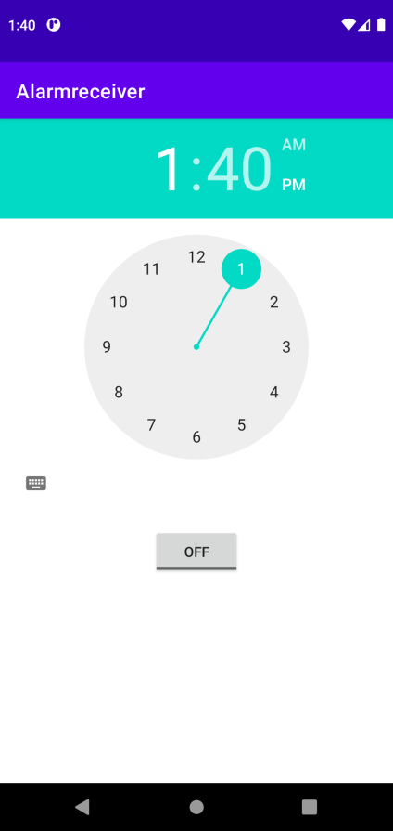

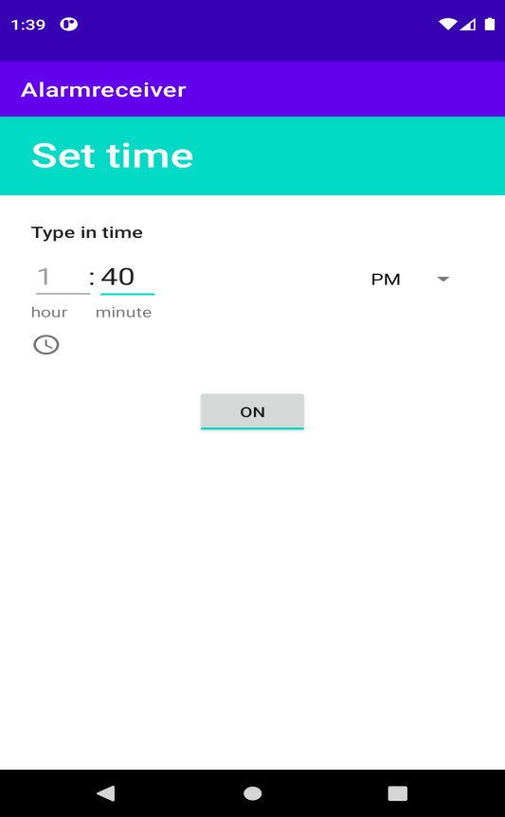

RESULT:
Thus Android Application that creates Alarm Clock is developed and executed successfully.
Game - Tic Tac Toe
Expt. No: 10
Date:23/10/2021

Aim:
To develop a simple gaming application with multimedia support

Software and Hardware Requirements:
Software:
- Android Studio
- Java
Hardware:
- Preferably 8GB+ RAM Laptop/Desktop

Algorithm:
1. Open Android Studio and create a new project.
2. Select Empty Activity.
3. Create a function onClick() to add user input as ‘x’ or ‘o’ based on the player.
4. Create a function checkWin() to check if any of the three columns/ rows/ diagonals are having the same value.
5. Create separate functions for player 1 and 2 wins .
6. Within player wins ,add audio using Mediaplayer.
7. Use functions like .start(), . create() and .release() to play and pause the audio.
8. Finally, run the code

Code:

MainActivity.java:
package com.example.tictactoe;

import androidx.appcompat.app.AppCompatActivity;

import android.media.MediaPlayer;
import android.os.Bundle;
import android.view.View;
import android.widget.Button;
import android.widget.ImageSwitcher;
import android.widget.ImageView;
import android.widget.TextView;
import android.widget.Toast;

public class MainActivity extends AppCompatActivity implements View.OnClickListener {

private Button[][] buttons = new Button[3][3];

private boolean player1Turn = true;

private int roundCount;

private int player1Points;
private int player2Points;

private TextView textViewPlayer1;
private TextView textViewPlayer2;
MediaPlayer winner;

@Override
protected void onCreate(Bundle savedInstanceState) {
super.onCreate(savedInstanceState);
setContentView(R.layout.activity_main);

textViewPlayer1 = findViewById(R.id.text_view_p1);
textViewPlayer2 = findViewById(R.id.text_view_p2);

for (int i = 0; i < 3; i++) {
for (int j = 0; j < 3; j++) {
String buttonID = "button_" + i + j;
int resID = getResources().getIdentifier(buttonID, "id", getPackageName());
buttons[i][j] = findViewById(resID);
buttons[i][j].setOnClickListener(this);
}
}

Button buttonReset = findViewById(R.id.button_reset);
buttonReset.setOnClickListener(new View.OnClickListener() {
@Override
public void onClick(View v) {
resetGame();
}
});
}

@Override
public void onClick(View v) {
if (!((Button) v).getText().toString().equals("")) {
return;
}

if (player1Turn) {
// textViewPlayer1.setImageResource(R.drawable.yellow);
((Button) v).setText("X");
} else {
((Button) v).setText("O");
//textViewPlayer2.setImageResource(R.drawable.yellow);
}

roundCount++;

if (checkForWin()) {
if (player1Turn) {
player1Wins();
} else {
player2Wins();
}
} else if (roundCount == 9) {
draw();
} else {
player1Turn = !player1Turn;
}

}

private boolean checkForWin() {
String[][] field = new String[3][3];

for (int i = 0; i < 3; i++) {
for (int j = 0; j < 3; j++) {
field[i][j] = buttons[i][j].getText().toString();
}
}

for (int i = 0; i < 3; i++) {
if (field[i][0].equals(field[i][1])
&& field[i][0].equals(field[i][2])
&& !field[i][0].equals("")) {
return true;
}
}

for (int i = 0; i < 3; i++) {
if (field[0][i].equals(field[1][i])
&& field[0][i].equals(field[2][i])
&& !field[0][i].equals("")) {
return true;
}
}

if (field[0][0].equals(field[1][1])
&& field[0][0].equals(field[2][2])
&& !field[0][0].equals("")) {
return true;
}

if (field[0][2].equals(field[1][1])
&& field[0][2].equals(field[2][0])
&& !field[0][2].equals("")) {
return true;
}

return false;
}

private void player1Wins() {
player1Points++;
winner = MediaPlayer.create(MainActivity.this,R.raw.win);
winner.start();
Toast.makeText(this, "Player 1 wins!", Toast.LENGTH_SHORT).show();
updatePointsText();
//winner.release();
resetBoard();

}

private void player2Wins() {
player2Points++;
winner = MediaPlayer.create(MainActivity.this,R.raw.win);
winner.start();
Toast.makeText(this, "Player 2 wins!", Toast.LENGTH_SHORT).show();
updatePointsText();
resetBoard();

}

private void draw() {
Toast.makeText(this, "Draw!", Toast.LENGTH_SHORT).show();
resetBoard();
}

private void updatePointsText() {
textViewPlayer1.setText("Player 1: " + player1Points);
textViewPlayer2.setText("Player 2: " + player2Points);

}

private void resetBoard() {
for (int i = 0; i < 3; i++) {
for (int j = 0; j < 3; j++) {
buttons[i][j].setText("");
}
}
roundCount = 0;
player1Turn = true;
}

private void resetGame() {
player1Points = 0;
player2Points = 0;
updatePointsText();
resetBoard();
}

@Override
protected void onSaveInstanceState(Bundle outState) {
super.onSaveInstanceState(outState);

outState.putInt("roundCount", roundCount);
outState.putInt("player1Points", player1Points);
outState.putInt("player2Points", player2Points);
outState.putBoolean("player1Turn", player1Turn);
}

@Override
protected void onRestoreInstanceState(Bundle savedInstanceState) {
super.onRestoreInstanceState(savedInstanceState);

roundCount = savedInstanceState.getInt("roundCount");
player1Points = savedInstanceState.getInt("player1Points");
player2Points = savedInstanceState.getInt("player2Points");
player1Turn = savedInstanceState.getBoolean("player1Turn");
}
}

activity_main.xml
<?xml version="1.0" encoding="utf-8"?>
<LinearLayout xmlns:android="http://schemas.android.com/apk/res/android"
xmlns:app="http://schemas.android.com/apk/res-auto"
xmlns:tools="http://schemas.android.com/tools"
android:layout_width="match_parent"
android:layout_height="match_parent"
android:orientation="vertical"
tools:context="com.example.tictactoe.MainActivity">

<RelativeLayout
android:layout_width="match_parent"
android:layout_height="wrap_content">
<TextView
android:id="@+id/text_view_p1"
android:layout_width="fill_parent"
android:layout_height="wrap_content"
android:freezesText="true"
android:text="Player 1: 0"
android:textSize="30sp" />
<TextView
android:id="@+id/text_view_p2"
android:layout_width="fill_parent"
android:layout_height="wrap_content"
android:freezesText="true"
android:text="Player 1: 0"
android:layout_below="@+id/text_view_p1"
android:textSize="30sp" />

<Button
android:id="@+id/button_reset"
android:layout_width="wrap_content"
android:layout_height="wrap_content"
android:layout_alignParentEnd="true"
android:layout_centerVertical="true"
android:layout_marginEnd="33dp"
android:text="reset"
android:layout_alignParentRight="true"
android:layout_marginRight="33dp" />

</RelativeLayout>

<LinearLayout
android:layout_width="match_parent"
android:layout_height="0dp"
android:layout_weight="1">

<Button
android:id="@+id/button_00"
android:layout_width="0dp"
android:layout_height="match_parent"
android:layout_weight="1"
android:freezesText="true"
android:textSize="60sp" />

<Button
android:id="@+id/button_01"
android:layout_width="0dp"
android:layout_height="match_parent"
android:layout_weight="1"
android:freezesText="true"
android:textSize="60sp" />

<Button
android:id="@+id/button_02"
android:layout_width="0dp"
android:layout_height="match_parent"
android:layout_weight="1"
android:freezesText="true"
android:textSize="60sp" />

</LinearLayout>

<LinearLayout
android:layout_width="match_parent"
android:layout_height="0dp"
android:layout_weight="1">

<Button
android:id="@+id/button_10"
android:layout_width="0dp"
android:layout_height="match_parent"
android:layout_weight="1"
android:freezesText="true"
android:textSize="60sp" />

<Button
android:id="@+id/button_11"
android:layout_width="0dp"
android:layout_height="match_parent"
android:layout_weight="1"
android:freezesText="true"
android:textSize="60sp" />

<Button
android:id="@+id/button_12"
android:layout_width="0dp"
android:layout_height="match_parent"
android:layout_weight="1"
android:freezesText="true"
android:textSize="60sp" />

</LinearLayout>

<LinearLayout
android:layout_width="match_parent"
android:layout_height="0dp"
android:layout_weight="1">

<Button
android:id="@+id/button_20"
android:layout_width="0dp"
android:layout_height="match_parent"
android:layout_weight="1"
android:freezesText="true"
android:textSize="60sp" />

<Button
android:id="@+id/button_21"
android:layout_width="0dp"
android:layout_height="match_parent"
android:layout_weight="1"
android:freezesText="true"
android:textSize="60sp" />

<Button
android:id="@+id/button_22"
android:layout_width="0dp"
android:layout_height="match_parent"
android:layout_weight="1"
android:freezesText="true"
android:textSize="60sp" />

</LinearLayout>

</LinearLayout>

SAMPLE I/O :

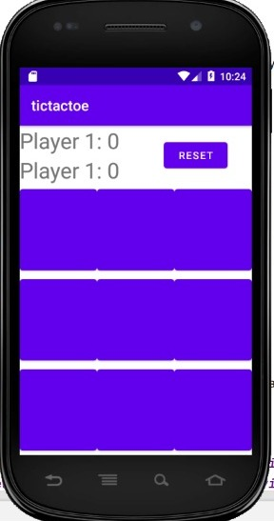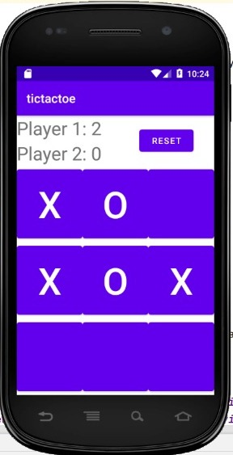
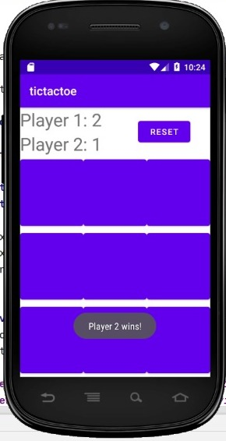

RESULT:
Thus a simple gaming application with multimedia support has been build and executed successfully .

